Websites & Blogs with

Adapted from Tutorial

CREATE AN ACCOUNT

- Visit http://education.weebly.com/drand and sign up for an account in the Get Started Now box..I
- the black bar at top, click More and then Weebly.

CHOOSE A THEME

- Choose a theme from the options shown; filter the themes by using the criteria options in the upper right corner

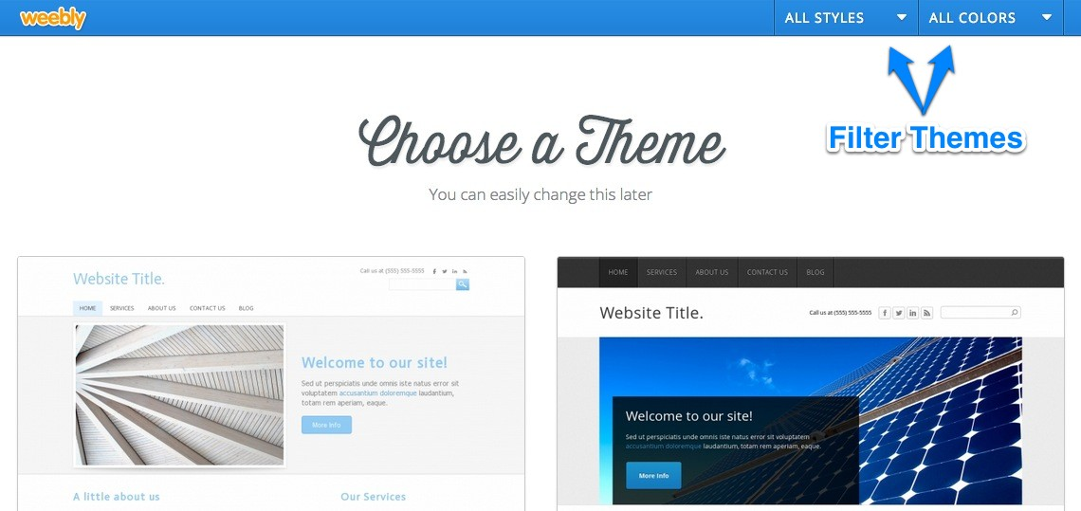

SET A WEBSITE ADDRESS

- Choose your website domain; Weebly offers free website hosting if you use a website address that ends in .weebly.com, but you get to choose the first part
  - Enter the website address of your choice and see if it is available; if so, click . Click .

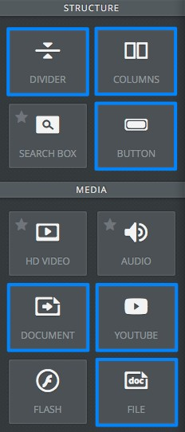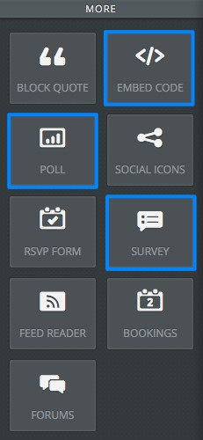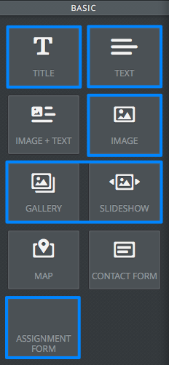CONSTRUCT YOUR SITE!

- Now, it’s time to construct your site! Simply drag-and-drop the following elements onto the content area of your website to make what you envisioned earlier.
- Visit the Help Center http://help.weebly.com/ for guidance on how to use each element. Elements with a star in the upper left are part of the paid vesion.

TEXT EDITING TOOLBAR

When working with text elements, you should see a toolbar that allows you to change the formatting of your text, including bolding, italicizing, underlining, hyperlinking, color, size, justification, and bulleted or numbered lists.

ADDING PAGES/BLOG

Click Pages tab at the top of the window. There are two kinds of pages: static pages (contain information that does not change frequently) and blog pages. The blog pages are interactive. Blogs allow you to post new articles periodically in a chronological order. Blog pages also have comment sections that allow students to comment on the posted content.

- A new page appears at the bottom of the list by default, if this is not where you want it, drag-and- drop the new page up to the new location.
- Sub-Pages are just like normal pages, except that they appear in a drop-down menu beneath another page in the site's navigation menu. To create a sub-page, drag the page underneath the page you want to make a sub-page of and also drag it a bit over to the right until it clicks in place.
- 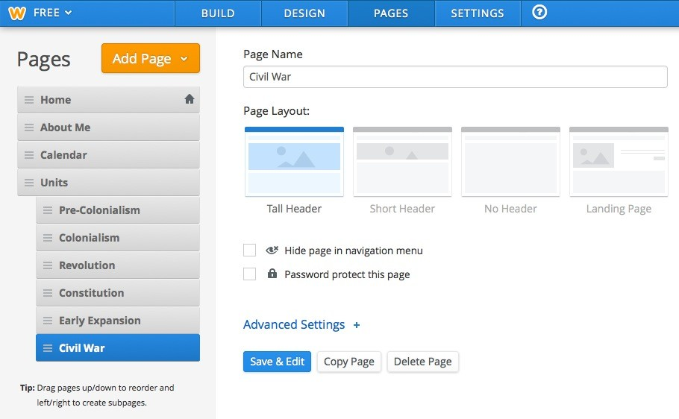All pages or blog created shows on the navigation menu. You can hide it checking the box beside
. This is helpful for
pages you want to link from another page, but not appear in the menu bar.
- There are usually four different page layouts available; they offer different header options, including a page layout with no header at all. This can help to add variety to your web pages. Experiment with the different layouts to find the best for each. (The Landing Page option is usually used for the home page!)

CREATING LINKS TO A WEBSITE, PAGE, FILE, OR E-­‐MAIL

You can link both text and images in Weebly
- Simply highlight the text or click on an image.
- Click on the Link icon in the Elements Option bar.
- Choose from the list (a pages from your site, a website, file upload, or e-mail address).
- Type in the info (e.g. website URL) and click Save.

PUBLISHING YOUR WEBSITE

Your website and/or changes to it will not appear on the public version of your site unless and until you publish it.
In order to do this, click on the Publish
button and following the prompts.

TIPS & SUGGESTIONS
- Have an idea of your site structure and contents before creating your site.
- Create a Weebly folder to store all the images and
documents that you use for your site.
- When creating documents for downloading (File element), convert Word documents to PDF files.

IMAGE PERFECT: WORKING WITH IMAGES

When you click on any image on your site, you will see an "Edit Image" button. When you click on this button, it will open up the Image Perfect interface.

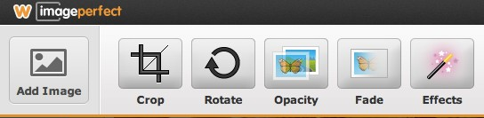

From here you can:

- Add images from your hard drive, Flickr, or a website
- Resize, crop, rotate and align the images
- Add effects like changing opacity, adding a fade, or adding burnt or polaroid borders
- Add multiple lines of text, position them anywhere, and choose from a wide selection of fonts
- Add text effects like gradients, patterns, and a shadow or glow
- Change the background to be a solid color, gradient or pattern
- Set different header images for different pages

- Go to FILE ⇒ PRINT ⇒ PDF pull down menu (bottom left corner) ⇒ select Save As PDF.
- You cannot “drag” external things into Weebly; everything must be uploaded using the Elements Option bar.
- Use the Divider, a simple horizontal line (in the More section), to create sections on your pages.
- Download a back-up of your site (Settings>Archive)
- Remember: The Help Section is your friend. http://help.weebly.com/

